Palliative Club Annual Report 2024-2025.

The palliative club handed over a sewing machine to a financially backward family as a source of self-employment. This kind of attempts engage students in meaningful works that can restore a sense purpose and dignity, combating feelings of helplessness and isolation. It allows the individuals to feel productive and valued members of society.



13 students from the college participated in the homecare program organized by Daya palliative care Perambra. It provides the students with a deeper understanding of palliative care practices and challenges faced by patients and their families. To witness the implementation of patients cantered care emphasizing respect, dignity and autonomy. It helps the students to understand how care plans are tailored to individual patients’ needs and preferences.

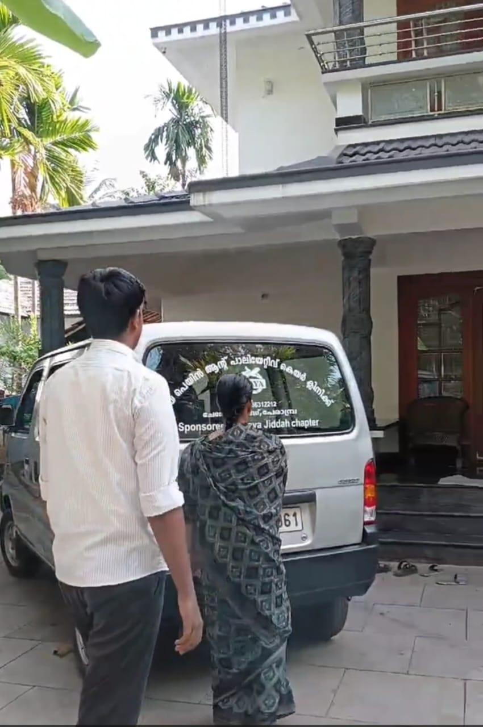

Students participated in the home care volunteers training programme held at Daya Palliative care Perambra. It offers unique opportunity to contribute the wellbeing of patients and their families. It also provides opportunities for students to present their ideas about future palliative care programmes.

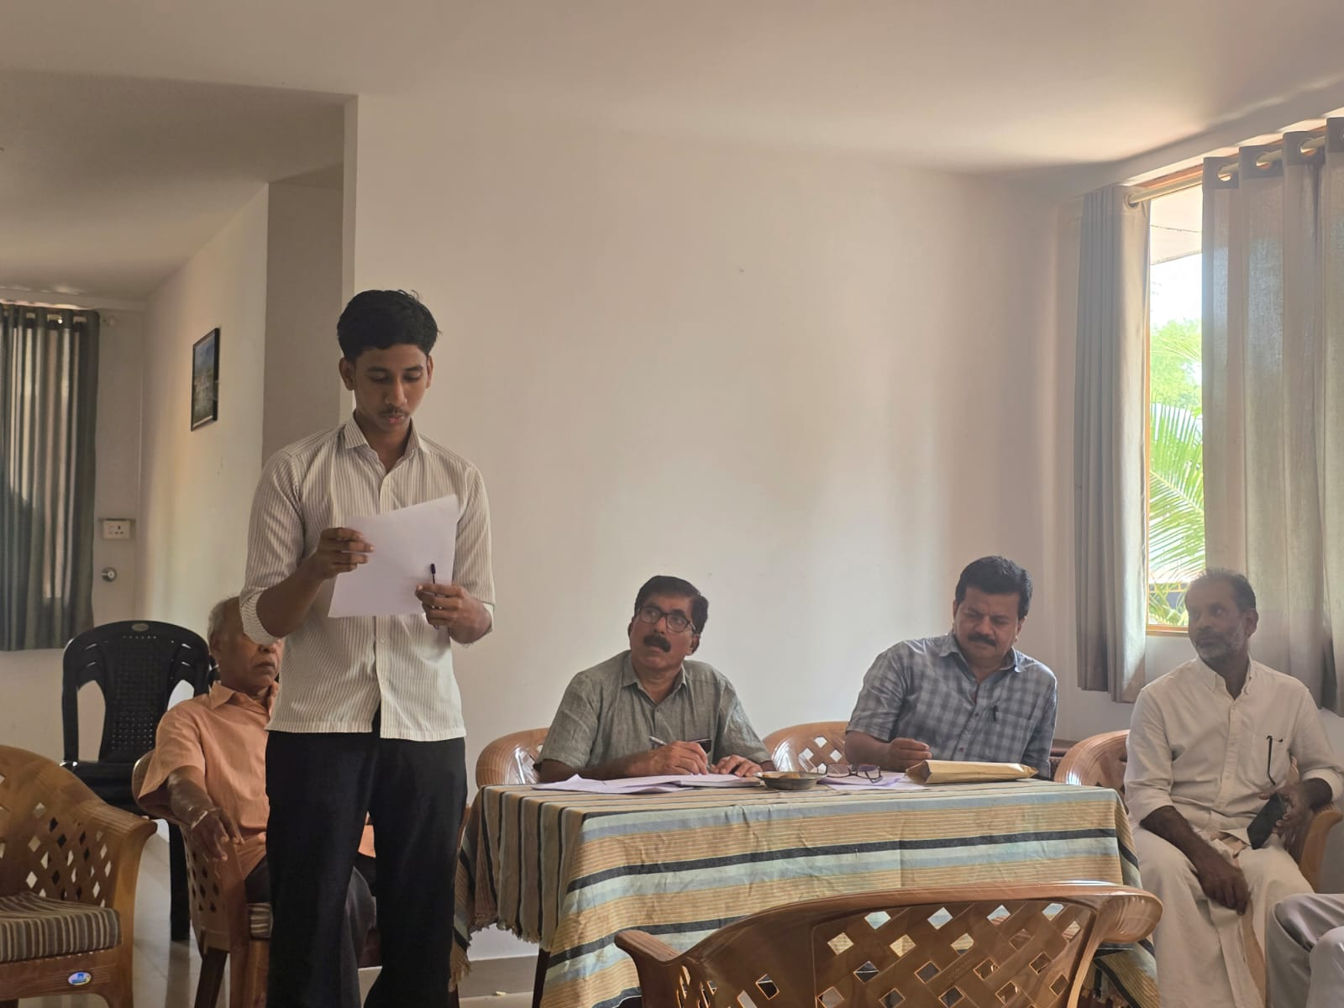

The volunteers of palliative club participated in the fund collection for the palliative patients near Perambra city.

